|  |
| --- |
|  |
| 新概念 3 册 |
| Lesson46 |

Lesson 46 Do it yourself

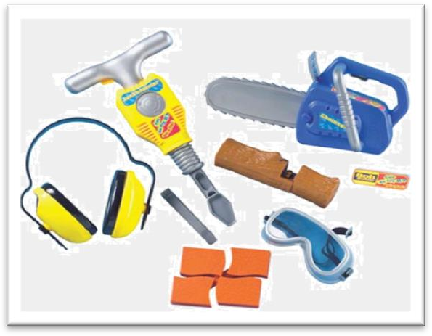

**plead [pli:d]**

**v. 以某事为借口**

plead pleaded pleaded

plead pled pled

plead ignorance / illness / a headache / tiredness / insanity Ellie pleaded tiredness and went to bed very early.

He could not ignorance as his excuse; he should have known what was happening in his department.

(A) plead (B) resort

(C) petition (D) reproach plead for sth.

He knelt in front of the king, pleading for mercy. plead with sb. to do sth.

I pleaded with him to stay, but he turned his back on me.

ignorance ['ɪgnərəns]

**n. 无知，不知道**Ignorance is bliss. be ignorant of ...

Darwin had a phrase to describe those ignorant of evolution: they “look at an organic being as a savage looks at a ship, as at something wholly beyond his comprehension.”

Ignorance is bliss. **be ignorant of ... ignore**

neglect

When I saw Jane, I stopped and smiled, but she me and walked on.

(A) refused (B) ignored

(C) denied (D) missed

The joys of travel, having long the disabled, are opening up to virtually anyone who has the means.

(A) omitted B) missed

(C) neglected D) discarded

newlyweds [n'ju:lɪwedz]

**n. 新婚夫妇**

newlyweds

fiancé fiancée

husband-to-be bride-to-be

groom / bridegroom bride

groomsman best man

bridesmaid maid of honor

novice ['nɒvɪs]

**n. 新手**

beginner / learner

The woman immediately behind the two cars happened to be a learner. ‘nov’=new novel a novel idea

novelty The car was a novelty in 1900. innovate innovation innovate in technique

renovate renovation

The Imperial Palace is under renovation.

consumer [kən'sju:mə(r)]

**n. 消费者**

consume consumption

customer client

consumer patron / regular

subscriber bargain hunter

creative [kri'eɪtɪv]

**adj. 创造性的，有创造力的**

creativity inventive

imaginative imaginary

She is a very student. She’s always talking about travelling to outer space.

(A) imaginary (B) imaginative

(C) imaginable (D) imagining creativity inventive

imaginative imaginary

original inspired

resourceful full of ideas

clog [klɒg]

**v. （粘稠的东西）堵塞住……**

clog sth. (up) with …

The pipe was clogged (up) with mud.

jam block obstruct

A crowd of people jammed / blocked / obstructed the road. thwart

Harry knew that nothing could thwart his plans. hamper hinder impede

Higher interest rates could hamper / hinder / impede economic growth.

delusion [dɪ'lu:ʒn]

**n. 错觉**

be / live under the illusion / delusion that ...

Even he still lives under the illusion that country life is somehow superior to town life. The worst thing about the do-it-yourself game is that sometimes even men live under the delusion that they can do anything, even when they have repeatedly been proved wrong. allusion

He resents any allusion to his baldness. hallucination

The high fever gave her hallucinations.

mirage

**海市蜃楼**

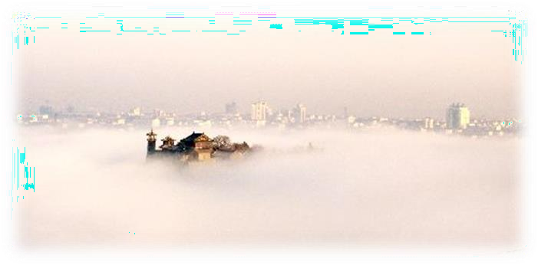

**adjustment [ə'dʒʌstmənt]**

**n. 调节，调整**

make adjustments to ...

The room was full of dancers, all making last-minute adjustments to their costumes. adjust (A) to B

You can adjust the belt to the size you want.

Some animals adjust (themselves) to their environment by instinct. adapt (A) to B

Novels are often adapted to the stage.

She couldn’t adapt (herself) to eating fish every day. adaptation

amend

amend a bill / rule / law / document amendment

nag [næg]

**v. 数落，唠叨**

nag (at) sb.

His wife nagged (at) him all day long. bitch at sb.

Stop bitching at me!

complain/moan/grouch about sth.

chatter murmur mumble

He was still mumbling something about hospitals at the end of the party when he slipped on a piece of ice and broke his left leg.

So great is our passion *for doing things for ourselves*, that we are becoming increasingly less dependent on specialized labour.

Our passion for doing things for ourselves is so great that … passion

his passion for table tennis his passion for the girl passionate

enthusiasm for … enthusiastic

zest for … zestful

zeal for … zealous

ardor for … ardent

do sth. for oneself

The following example of 'sick humor' will enable you to judge for yourself. oneself

I made these curtains myself. in person

You have to sign for it in person. personally

The President wrote to us personally to thank us for our hard work. increasingly: more and more

be becoming increasingly + adj.

It is also becoming increasingly difficult to deal with the problem of traffic in towns.

As a result of all these factors, governments are becoming increasingly dependent on biologists and social scientists for planning the appropriate programs and putting them into effect.

造句：有机食品正在变得越来越流行。

Organic food is becoming increasingly popular.

造句: 人们正在变得越来越了解 (aware) 国家和国际间的问题。People are becoming increasingly aware of national and international issues. be dependent on …

be independent of …

We are becoming increasingly independent of specialized labor.

造句: 我母亲住得这么远以至于我们很少 (hardly ever) 见到她。

So far away does my mother live that we hardly ever see her.

造句: 我们对因特网的热情是如此的高涨以至于我们对电视越来越没有兴趣了。

So great is our passion for the Internet that we are becoming increasingly less interested in the television.

To plead ignorance of a subject is no longer a legitimate / justifiable excuse. countless / numerous

There are countless people who, ever since their early years, have learned to associate snails with

food.

There are numerous people, who ... take-home pay

a can’t-be-put-down book a wait-and-see policy

a good-for-nothing man

Armed with the right tools and materials, newlyweds gaily embark on the task of decorating their own homes.

Armed with a torch, the vicar went up into the clock tower to see what was going on. reading / writing / building materials

gaily: cheerfully / happily gay / homosexual

He is gay. lesbian

heterosexual / straight embark on …

We embarked on the ship for Shanghai. start on sth. set about sth. disembark from …

Passengers began to disembark from the ferry.

Men, *particularly*, spend hours of their leisure time installing their own fireplaces, laying out their own gardens; building garages and making furniture.

particularly / especially / in particular lay out ...

While they were laying it out on the decks.

Lay out the map on the table and let’s have a look. arrange

Diamond necklaces and rings had been beautifully arranged on a background of black velvet. The gardens were laid out with lawns and flower beds.

so ... as to do

I can only trust him so far. I got a surprise for you.

Yeah? I got one for you too.

I’ve watched you do business for years, but I thought there was a limit to how sick you could … How could you, Linus? How could you do what you did to me and to her? How could you go that far? What the hell makes you think you have the right?

Habit.

as / so far as I know

as / so far as I can remember as / so far as I can see

build: assemble

Shops cater for the do-it-yourself craze *not only by running special advisory services for novices, but by offering consumers bits and pieces which they can assemble at home*.

cater for ...

Schools often fail to cater for the needs of gifted children. It is a resort that clearly caters for the well-off.

craze: fad / mania

The college runs summer courses. services for novices

the institute for the destitute Haste makes waste.

Man proposes, God disposes.

Genius is one percent inspiration and ninety-nine percent perspiration.

— Thomas Edison

outlet n. means of releasing energy, strong feelings, etc.（精力、强烈情感等的）发泄的途径outlet for …

Children need an outlet for their energy.

pent-up adj. pent-up feelings or energy have not been expressed or used for a long time（情感、精力等）被压抑的，郁积的

He needs an outlet for all that pent-up anger.

not 与 all, every, everything, everyone, both 连用多表示部分否定

All that glitters is not gold.

Every machine here is not produced in our plant. Both of the substances do not dissolve in water. He was born an idiot.

He was born idiotic. He died a beggar.

He died poor. tend to do

Women tend to live longer than men. have a tendency to do

Women have a tendency to live longer than men.

Even men who can hardly drive a nail in straight are supposed to be born electricians, carpenters, plumbers and mechanics.

drive the posts into the ground

She had told him to come straight in if ever she failed to open the door and to leave the bread on the kitchen table.

Pick up the man at 1:00.

Meet her friends at the restaurant.

Make lunch for the man.

Do her errands after lunch.

M: We thought we'd all go out for lunch today. Can you be ready to leave at one o'clock? W: I have to pick up my car and do a couple of other errands. So I'll just come straight to the restaurant.

Q: What will the woman do?

Answer: (B) Meet her friends at the restaurant.

He is a born leader / musician. gifted / talented

Picasso was one of the most gifted / talented artists. have a gift for sth.

have an aptitude for sth.

have a gift / an aptitude for languages / painting / music / dancing etc.

When lights fuse, furniture gets rickety, pipes get clogged, or vacuum cleaners fail to operate, some woman assume that their husbands will somehow put things right.

rickety: shaky

somehow adv. 1. in some way, or by some means, although you do not know how 以某种方式

Don't worry, we'll get the money back somehow.

somehow adv. 2. for a reason that you do not know or understand 不知怎么搞的，出于未知的原因

Somehow, I don't feel I can trust him.

…, this one must have been in the possession of a private collector and somehow managed to escape.

And I couldn’t remember what it felt like when I could not walk down the street without holding her hand.

I mean she was the same woman I fell in love with, she hadn’t changed. But somehow everything’s different. We’ve lost something along the way.

put … right / in order 使……恢复正常

**put … out of order 使……出故障**

As the floods had put the telephone out of order, we could not find out how they were managing.

The worst thing about the do-it-yourself game is that sometimes even men live under the delusion *that they can do anything*, even when they have repeatedly been proved wrong. a question of …

She is so diligent and talented that her success is only a question of time. There would definitely be some job losses; it was just a question of how many. a matter of time

a matter of life and / or death a matter of personal taste

I can’t take the money. It is a matter of principle. as … as anything (else)

It’s as easy as anything (else). He’s as fat as anything (else).

call sb.⇔in to ask sb. to come and help you with a difficult situation 叫某人来帮忙

Your father is very sick. You’d better call in a doctor at once. look at … = examine …

have a look at …

have a close look at …

get round / around to sth./ doing

**有时间（找到时间）做某事**

It's new.

It's dull.

It's not clean.

It has a broken handle.

W: I'm having trouble slicing the bread with this knife.

M: Oh. Sorry about that. I haven't gotten around to sharpening it yet. Q: What can be inferred about the knife?

Answer: (B) It’s dull.

not hear of sth. 不同意某事

I wanted to pay but she wouldn't hear of it.

I would not hear of the suggestion that I call in a man to look at our lawn mower.

… and examined it carefully

As far as I could see, it needed only a minor adjustment: a turn of a screw here, a little tightening up there, a drop of oil and it would be as good as new.

as far as I can see

as good as ... : almost / nearly

The injured man is as good as dead. Everything is as good as settled.

Thirteen is not as good as one, but it's better than nothing. The waiter refused to wait on us.

The waiter refused to serve us.

If we see the unutterable, it is unwise to try to utter it, … We only help those who really need help.

…, so I decided to take it apart. be littered / cluttered with …

The floor was littered / cluttered with broken glass.

Even though the road was littered with boulders and pitted with holes, Bruce was not in the least perturbed.

litter / clutter

Broken glass littered / cluttered the floor.

There is always hope that in its labyrinth of musty, dark, disordered rooms a real rarity will be found amongst the piles of assorted junk that litter the floors.

be pleased with ...

Robert was delighted to see me and equally pleased with my little gift.

I felt especially pleased with my wonderful bargain―until I got back to the ship. trace: track down 找到

The president vowed to trace / track down those responsible for the bombing. be faced with ...

be confronted with ...

China is faced / confronted with the problem of overpopulation.

I was not surprised *to find that machine still refused to work after I had reassembled it*, for the simple reason *that I was left with several curiously shaped bits of metal which did not seem to fit anywhere*.

for the simple reason that …

= simply because ...

People who work in offices are frequently referred to as ‘white collar workers’ for the simple reason that they usually wear a collar and tie to go to work.

leave sb. with sth.

Oddly shaped forms that are suspended from the ceiling and move in response to a gust of wind are quite familiar to everybody.

fit: go

The key won’t fit / go in the lock. in despair 绝望地

He killed himself in despair.

With this faith, we will be able to hew out of the mountain of despair a stone of hope. despair of n. / doing

The teachers began to despair of him. Mike despaired of ever seeing her again. pass: go by / elapse

An idle youth, a needy age. As you can imagine, …

Buried somewhere in deep grass there is a rusting lawn mower which I have promised to repair one day.